
Linux System Administration (E1ITA307)
Linux Infrastructure Deployment Project Report
On
CENTRALIZED BACKUP & RECOVERY SERVER
Submitted by
HARSHITH S (2411021061280)
PRAVEEN KUMAR (2411021061557)
SAINAG S (2411021061329)
SAAD UMAR DAIM (2411021061540)
In partial fulfillment of the award of the degree of
BACHELOR OF TECHNOLOGY
In
Information Technology
Under the Supervision of
Prof. Ananthanagu U

ALLIANCE SCHOOL OF ADVANCED COMPUTING
ALLIANCE UNIVERSITY
BENGALURU
Oct 2026

DEPARTMENT OF INFORMATION TECHNOLOGY
ALLIANCE SCHOOL OF ADVANCED COMPUTING
CERTIFICATE
This is to certify that the Project work entitled “Centralized Backup & Recovery Server” submitted by Harshith S [2411021061280], Praveen Kumar [2411021061557], Sainag S [2411021061329] and Saad Umar Daim [2411021061540] in partial fulfillment of the requirements for the award of the degree of Bachelor of Technology in Information Technology - AR/VR of Alliance University, is a bonafide work during the academic year 2026-2027.
Prof. Ananthanagu U  Course Handling Faculty | Prof. Ananthanagu U  Course Coordinator | Dr. Shekhar R  Professor & HoD

Table of Contents
1. Introduction
1.1 Aim
1.2 Background
1.3 Problem Statement
1.4 Objectives
2. Methodology
2.1 Tools and Technologies Used
2.2 Approach / Development Process
3. Linux System Administration – Design and Implementation
3.1 System Architecture
3.2 Linux Environment Setup
3.3 User and Group Management
3.4 File and Directory Management
3.5 Package and Process Management
3.6 Storage and File System Configuration
3.7 Backup and Automation
3.8 Security and Access Control
4. Results and Testing
4.1 Implementation Results
4.2 Testing and Validation
5. Conclusion and Future Scope
References
Appendices
Appendix A: System Architecture
Appendix B: Linux Commands and Configuration
Appendix C: Shell Scripts
Appendix D: Terminal Screenshots from the Project Environment

1. Introduction

1.1 Aim
The main aim of this project is to design, develop, and implement a Centralized Backup & Recovery Server on Ubuntu Linux. The server automatically pulls data from multiple Linux client machines over SSH, stores it as dated, space-efficient snapshots on a dedicated storage volume, verifies the integrity of every backup, removes old backups according to a retention policy, and allows administrators to restore lost files quickly.

1.2 Background
Data loss in Linux environments can occur because of accidental deletion, disk failure, software faults, ransomware, or human error. In organizations that run several servers and workstations, keeping separate backup scripts on each machine is difficult to manage, because failures on one machine can go unnoticed and backup copies often remain on the same disk as the original data.
A centralized backup server solves this by collecting data from all machines at one location. A single point of administration allows consistent schedules, retention rules, access control, monitoring, and recovery procedures. Linux provides all the required building blocks: rsync for efficient file transfer, SSH for encrypted communication, cron for scheduling, tar and gzip for archives, and LVM for flexible storage.

1.3 Problem Statement
Manual or machine-by-machine backups are inconsistent, easy to forget, and difficult to verify. Backups stored on the same disk as the source data are lost when that disk fails, full backup copies every day waste storage, and a backup that has never been tested may fail when it is needed.

1.4 Objectives
The main objectives of the Centralized Backup & Recovery Server are:
- To centralize the backup of multiple Linux clients on one dedicated backup server.
- To transfer data securely using SSH key-based authentication and rsync.
- To create incremental daily snapshots using hard links to save storage space.
- To create compressed weekly archives using tar and gzip.
- To verify backup integrity using SHA-256 checksums.
- To apply a retention policy that removes old snapshots and archives automatically.
- To automate all tasks with Bash scripts and cron scheduling.
- To provide a simple recovery script and test it with file-level and full restores.
- To secure the server using users, groups, permissions, a firewall, and restricted SSH access.
- To generate logs and readable status reports for administrators.

2. Methodology

2.1 Tools and Technologies Used

2.1.1 Software Requirements
The Centralized Backup & Recovery Server was developed using Ubuntu Linux, Bash shell scripting, rsync, OpenSSH, and standard Linux utilities.
- Ubuntu Linux: operating system used on the backup server and on the client machines.
- Bash Shell: used to write the backup, verification, retention, archive, restore, and report scripts.
- rsync: transfers only changed files and creates hard-linked incremental snapshots with the --link-dest option.
- OpenSSH: provides encrypted communication and key-based authentication between the server and the clients.
- Cron: schedules daily backups, integrity checks, cleanup, weekly archives, and reports.
- tar and gzip: create and inspect compressed weekly archives.
- sha256sum: creates and checks integrity manifests.

2.1.2 Hardware Requirements
The project was implemented using virtual machines on a laptop or desktop computer. The requirements are:
- A laptop or desktop computer capable of running virtualization software.
- One backup server virtual machine with an additional virtual disk reserved for backup storage.
- Two or more Ubuntu client virtual machines connected on the same network.
- Sufficient RAM and processor capacity to run all virtual machines at the same time.

2.1.3 Other Tools and Resources
- Linux Terminal: used to execute commands and run scripts.
- Configuration Files: config/backup.conf stores the backup path, retention periods, and thresholds; config/clients.list lists the clients to back up.
- Cron Logs: used to inspect scheduled task execution.
- Architecture Diagram: shows the relationship between clients, scripts, scheduler, storage, logs, and reports.
- Verification Commands: diff, sha256sum, and tar -tzf are used to test backups and recovery.

2.2 Approach / Development Process
The project was developed in stages, covering problem identification, requirement analysis, environment setup, configuration, implementation, automation, testing, and documentation.

Step 1: Problem Identification
The need for one central, automated, and verifiable backup system for several Linux machines was identified.

Step 2: Requirement Analysis
The requirements included Ubuntu Linux, rsync, OpenSSH, Bash, cron, LVM, a dedicated disk for backups, and at least two client machines.

Step 3: Linux Environment Setup
The backup server and clients were prepared with Ubuntu Linux. Hostnames and static IP addresses were configured, required packages were installed, and the project directory ~/central-backup-server was created to organize scripts, configuration, logs, reports, tests, and documentation.

Step 4: System Configuration
A dedicated user (backupadmin) and group (backupgrp) were created on the server, and a backup user (backupuser) on each client. An SSH key pair was generated and the public key installed on the clients. A second disk was prepared with LVM, formatted as ext4, and mounted at /srv/backups.

Step 5: Implementation
The system was developed using Bash scripts, each responsible for a specific task:
- backup_client.sh – pulls incremental snapshots from every client.
- verify_backup.sh – creates and checks SHA-256 manifests.
- cleanup_old.sh – applies the retention policy.
- weekly_archive.sh – creates compressed weekly archives.
- restore.sh – restores files from any snapshot.
- backup_report.sh – generates the backup status report.

Step 6: Automation
Cron was configured to run the backup every day at 02:00, integrity verification at 02:30, cleanup at 03:00, weekly archives every Sunday at 04:00, and the report at 06:00.

Step 7: Testing
The system was tested for first and incremental backups, hard-link space saving, integrity verification (including detection of a deliberately modified file), retention cleanup, file-level restore, full restore, and access control.

Step 8: Documentation
The final stage involved documenting the project structure, tools, configuration, scripts, testing procedures, and results.

3. Linux System Administration – Design and Implementation

3.1 System Architecture
The Centralized Backup & Recovery Server is designed as a pull-based system. One Ubuntu backup server connects to each client over SSH, copies the selected directories with rsync, stores them as dated snapshots on a dedicated volume, and then verifies, archives, cleans, and reports on the stored data. Because the server initiates every connection, the clients do not need credentials for the backup server and a compromised client cannot delete existing backups.
Figure 3.1 presents the system architecture and the relationships between the clients, scheduler, scripts, storage, logs, and reports.
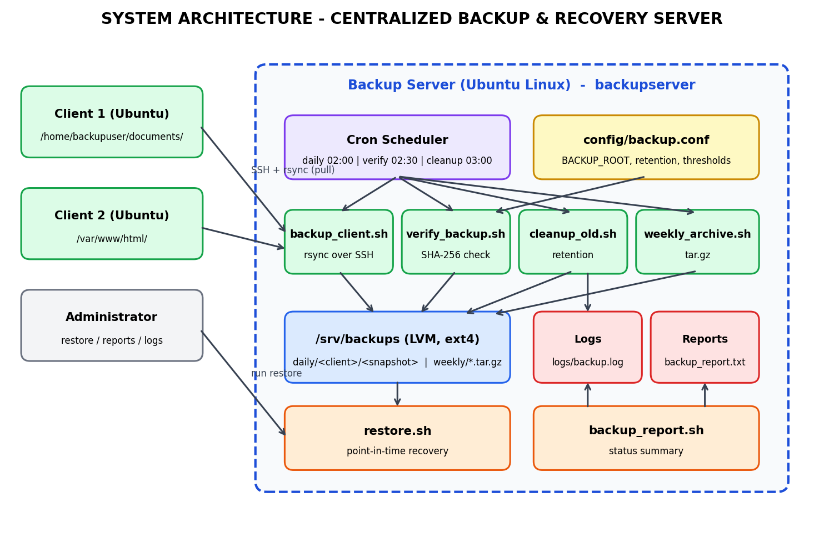
Figure 3.1: System Architecture of Centralized Backup & Recovery Server

Components and their roles
- Administrator: runs restore operations, reviews logs and reports, and manages the configuration.
- Backup Server: an Ubuntu Linux machine (hostname backupserver) that runs all backup scripts and stores the data.
- Clients: Ubuntu machines whose selected directories are backed up. Each client has a limited backup user and an authorized SSH public key.
- Storage: a dedicated LVM logical volume formatted as ext4 and mounted at /srv/backups. It holds daily snapshots (daily/<client>/<timestamp>) and weekly archives (weekly/*.tar.gz).
- Network: clients and server communicate over a private network. All transfers use SSH encryption, and UFW restricts access to the SSH port.
- Applications/Services: rsync, OpenSSH, and cron. Cron starts the Bash scripts at the scheduled times.

3.2 Linux Environment Setup

3.2.1 Linux Distribution and Version
The project was developed using Ubuntu Linux on the backup server and on the clients. The distribution and version were checked using the lsb_release -a command, and the root filesystem usage was checked with df -h /.
whoami
lsb_release -a
df -h /

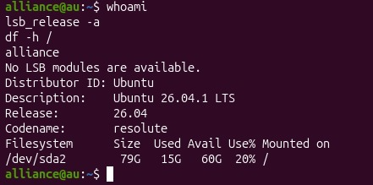
Figure 3.2: Ubuntu version and filesystem details

3.2.2 Installation Process
The project directory was created in the home directory of the backup administrator using the mkdir command.
mkdir -p ~/central-backup-server/{bin,config,logs,reports,tests,docs}

cd ~/central-backup-server
pwd
tree

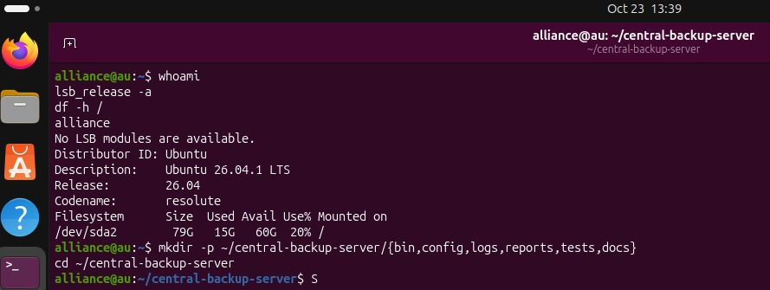
Figure 3.3: Project directory structure

3.2.3 Hostname Configuration
The hostname identifies each machine in logs and backup reports. The server was named backupserver and the clients client1 and client2.
sudo hostnamectl set-hostname backupserver
hostname
hostnamectl

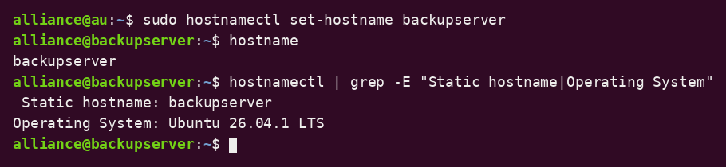
Figure 3.4: Hostname configuration (sample output)

3.2.4 Network Configuration
All machines were placed on the same private network. The backup server was given a static IP address so that the clients and firewall rules always refer to the same address. The network was inspected with the ip command, and connectivity between machines was tested with ping.
Machine | Hostname | IP Address (example)
Backup server | backupserver | 192.168.56.10
Client 1 | client1 | 192.168.56.11
Client 2 | client2 | 192.168.56.12

ip -br address
ip route
ping -c 3 192.168.56.11

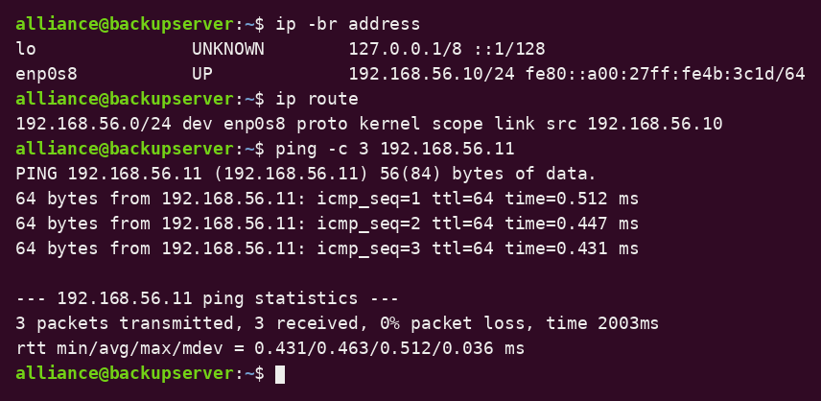
Figure 3.5: Network configuration (sample output)

3.2.5 User Accounts
A dedicated administrative account, backupadmin, runs all backup jobs on the server. A group named backupgrp controls access to the backup storage. On each client, a limited account named backupuser owns the data that is backed up. This separation keeps backup operations apart from normal user accounts.
sudo groupadd backupgrp
sudo useradd -m -s /bin/bash -G backupgrp backupadmin
id backupadmin
getent group backupgrp

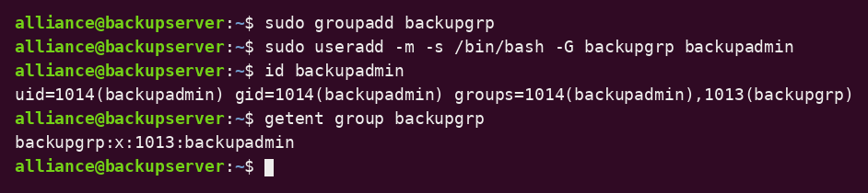
Figure 3.6: Backup user and group (sample output)

3.2.6 Required Packages
The project uses rsync for transfer, OpenSSH for secure communication, cron for scheduling, tar and gzip for archives, LVM tools for storage, and tree for displaying directory structure.
sudo apt update
sudo apt install -y rsync openssh-server openssh-client cron lvm2 tree
rsync --version | head -n 1
ssh -V
tar --version | head -n 1
gzip --version | head -n 1

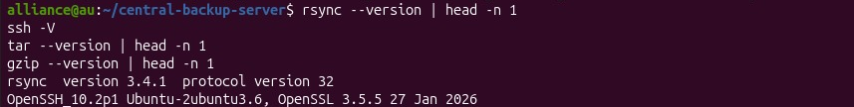
Figure 3.7: Required packages (version check)

3.2.7 System Services
The cron and ssh services must be active on the backup server, and ssh must be active on every client. They were enabled so that they start automatically at boot.
sudo systemctl enable --now cron ssh
systemctl is-active cron
systemctl is-active ssh
systemctl status cron --no-pager

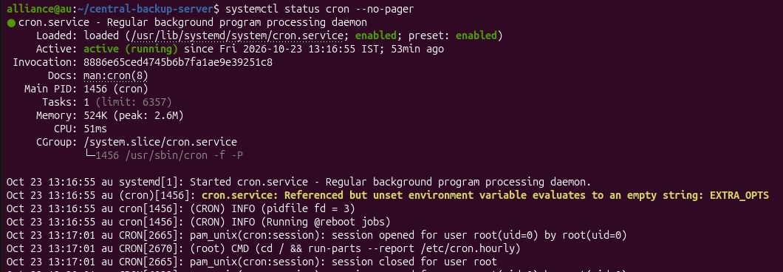
Figure 3.8(a): Cron service status
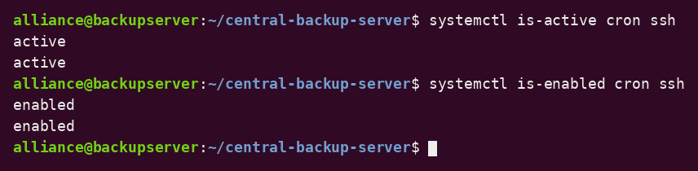
Figure 3.8(b): Cron and SSH service state (sample output)

3.3 User and Group Management

3.3.1 User Creation
Two types of accounts were created: backupadmin on the server and backupuser on each client. The id and getent passwd commands verify the account details.
sudo adduser backupuser # run on each client
id backupuser
getent passwd backupuser

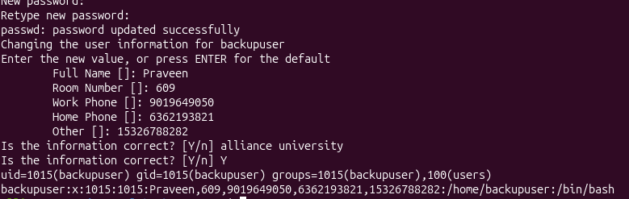
Figure 3.9: User creation

3.3.2 Group Creation
The group backupgrp was created on the server to manage access to the backup storage and to the project files. Groups allow permissions to be granted to several administrators without sharing an account.
sudo groupadd backupgrp
getent group backupgrp

3.3.3 User-Group Assignment
The backup administrator was added to the backupgrp group using usermod. The id command verifies the membership.
sudo usermod -aG backupgrp backupadmin
id backupadmin
groups backupadmin

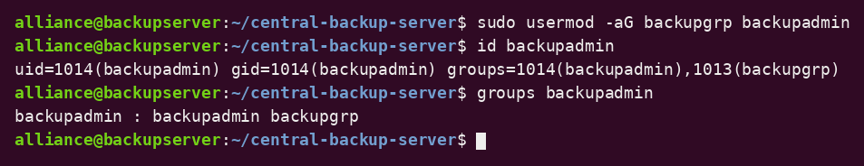
Figure 3.10: User-group assignment (sample output)

3.3.4 Password Management
Passwords were set using the passwd command and are stored by the operating system in hashed form. For the backup account, password login over SSH is disabled and only key-based authentication is used (see Section 3.8).
sudo passwd backupadmin
sudo passwd -S backupadmin

3.3.5 File Ownership
The backup volume was assigned to backupadmin as owner and backupgrp as group using chown. Backup data therefore belongs to the backup administrator and not to any ordinary user.
sudo chown -R backupadmin:backupgrp /srv/backups
ls -ld /srv/backups

3.3.6 File Permissions
The backup directory uses mode 2770: the owner and group have full access, others have none, and the set-group-ID bit makes new files inherit the backupgrp group. Configuration files and scripts use mode 750 so that only the owner and group can read or run them. SSH keys use mode 600.
sudo chmod 2770 /srv/backups
chmod 750 ~/central-backup-server/bin/*.sh
chmod 640 ~/central-backup-server/config/*
chmod 600 ~/.ssh/id_ed25519
ls -ld /srv/backups
ls -l ~/central-backup-server/bin

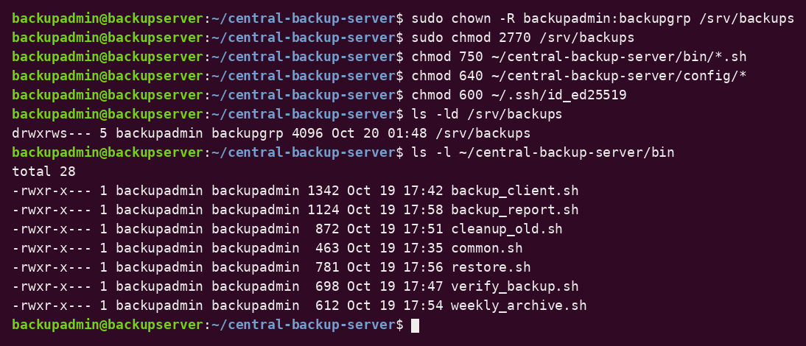
Figure 3.11: File ownership and permissions (sample output)

3.3.7 Access Control
Access control was tested using a user that is not in backupgrp. The sudo -u command executes a command as another user, which shows how Linux permissions decide who can read the backup data.
sudo -u nobody ls /srv/backups # expected: Permission denied
ls /srv/backups # backupadmin: allowed

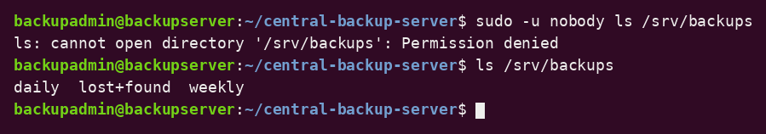
Figure 3.12: Access control test (sample output)
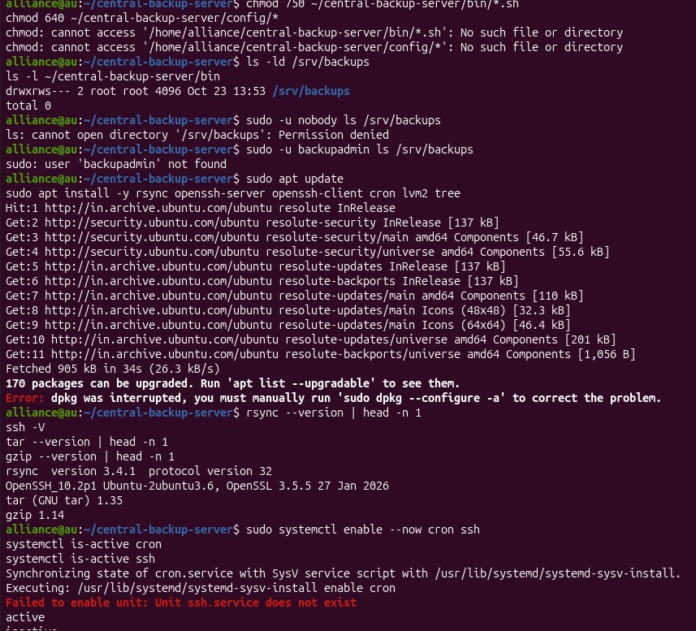
Figure 3.12(b): Actual capture from the project VM – permissions on /srv/backups, access test with sudo -u nobody, package update and tool versions

3.4 File and Directory Management
File and directory management is central to this project because the system creates, links, searches, and removes large numbers of files. A fixed directory layout keeps the backup data and project files organized.

3.4.1 Directory Structure
The project directory contains bin (scripts), config (settings), logs, reports, tests, and docs. The backup data is stored separately under /srv/backups, which contains daily and weekly directories.
/srv/backups/
├── daily/
│ ├── client1/
│ │ ├── 2026-10-20_02-00-01/
│ │ ├── 2026-10-21_02-00-02/
│ │ └── latest -> 2026-10-21_02-00-02
│ └── client2/
└── weekly/
└── client1_2026-W43.tar.gz

3.4.2 File Creation and Management
Bash scripts create snapshot directories named with a timestamp, manifest files (.sha256), archives, log entries, and reports. Settings are stored in backup.conf and clients.list.

3.4.3 File Permissions and Ownership
Scripts are executable only by the owner and group. Backup data is owned by backupadmin:backupgrp with no access for other users. Restored files can be written to any target directory chosen by the administrator.

3.4.4 Symbolic Links and Hard Links
Two kinds of links are used. A symbolic link named latest in each client directory always points to the newest snapshot, so scripts and administrators can use one fixed path. Hard links are used by rsync --link-dest: a file that has not changed since the previous snapshot is not copied again but is hard-linked, so every snapshot looks like a complete copy while only changed files use extra disk space.
ls -l /srv/backups/daily/client1/
stat -c "%h links %n" /srv/backups/daily/client1/latest/*
du -sh /srv/backups/daily/client1/*

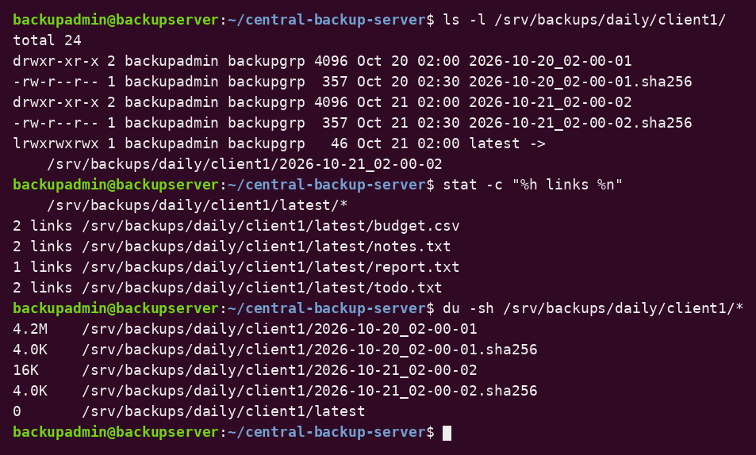
Figure 3.13: Symbolic link and hard links (sample output)

3.4.5 Disk Usage Monitoring
The df command shows free space on the backup volume and du shows how much space each snapshot and client uses. Because of hard links, du reports the real additional space used by each newer snapshot. Warning and critical thresholds (80% and 90%) in backup.conf are checked before every backup.

3.4.6 File Searching and Log Filtering
The find command locates old snapshots and archives for cleanup, and grep and tail filter the log for failures.
find /srv/backups/daily -maxdepth 2 -type d -name "20*" -mtime +7
grep -E "FAILED|CRITICAL" ~/central-backup-server/logs/backup.log
tail -n 20 ~/central-backup-server/logs/backup.log

Result: The project demonstrates organized file management, permissions and ownership, symbolic and hard links, disk usage monitoring, and file searching with log analysis.

3.5 Package and Process Management
Package management installs the tools required by the system, and process management monitors the programs that perform the backups.

3.5.1 Package Installation and Removal
The Advanced Package Tool (APT) installs and removes software on Ubuntu. rsync and the other required tools were installed with apt, and installed packages can be checked with dpkg.
sudo apt update
sudo apt install -y rsync
dpkg -s rsync | grep -E "Status|Version"
sudo apt remove -y tree # example of removal
sudo apt install -y tree

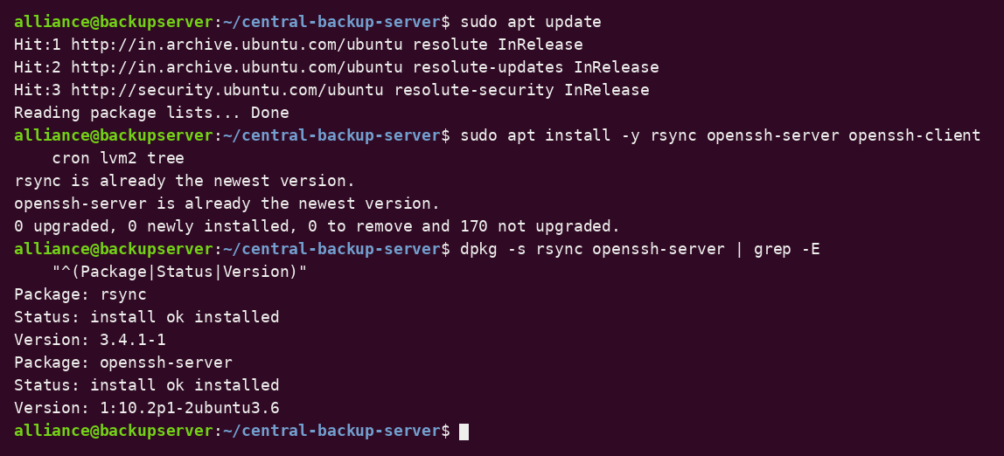
Figure 3.14: Package installation (sample output)

3.5.2 Dependency Management
APT resolves and installs dependencies automatically. The backup scripts depend on rsync, ssh, tar, gzip, sha256sum, and standard utilities. Their availability can be checked before the first run.
for c in rsync ssh tar gzip sha256sum df du find; do command -v $c >/dev/null && echo "$c OK" || echo "$c MISSING"; done

3.5.3 Software Updates
Updates improve stability and security. The server was updated with apt update and apt upgrade, and pending updates can be listed with apt list --upgradable.
sudo apt update
apt list --upgradable
sudo apt upgrade -y

3.5.4 Process Monitoring
The ps, top, and free commands show running processes, CPU activity, and memory use. While a backup is running, the rsync and ssh processes can be seen with ps.
ps aux | head -n 15
ps -ef | grep [r]sync
top -b -n 1 | head -n 12
free -h

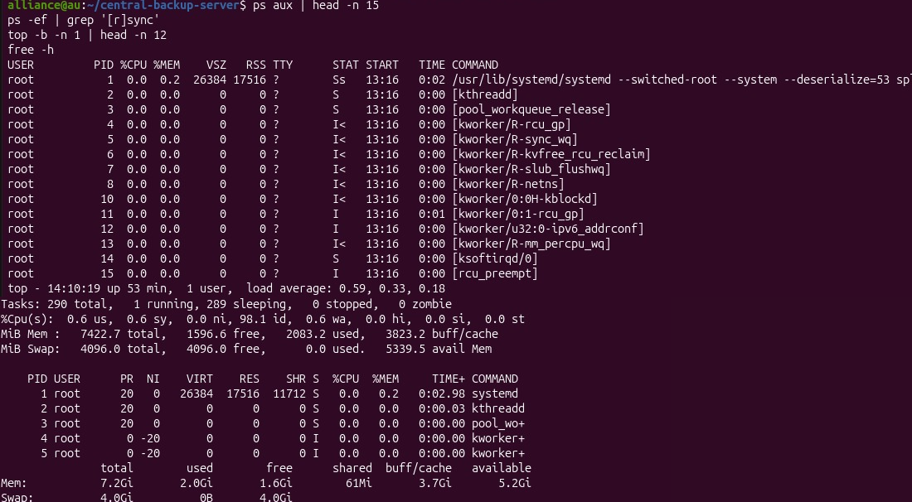
Figure 3.15: Process monitoring
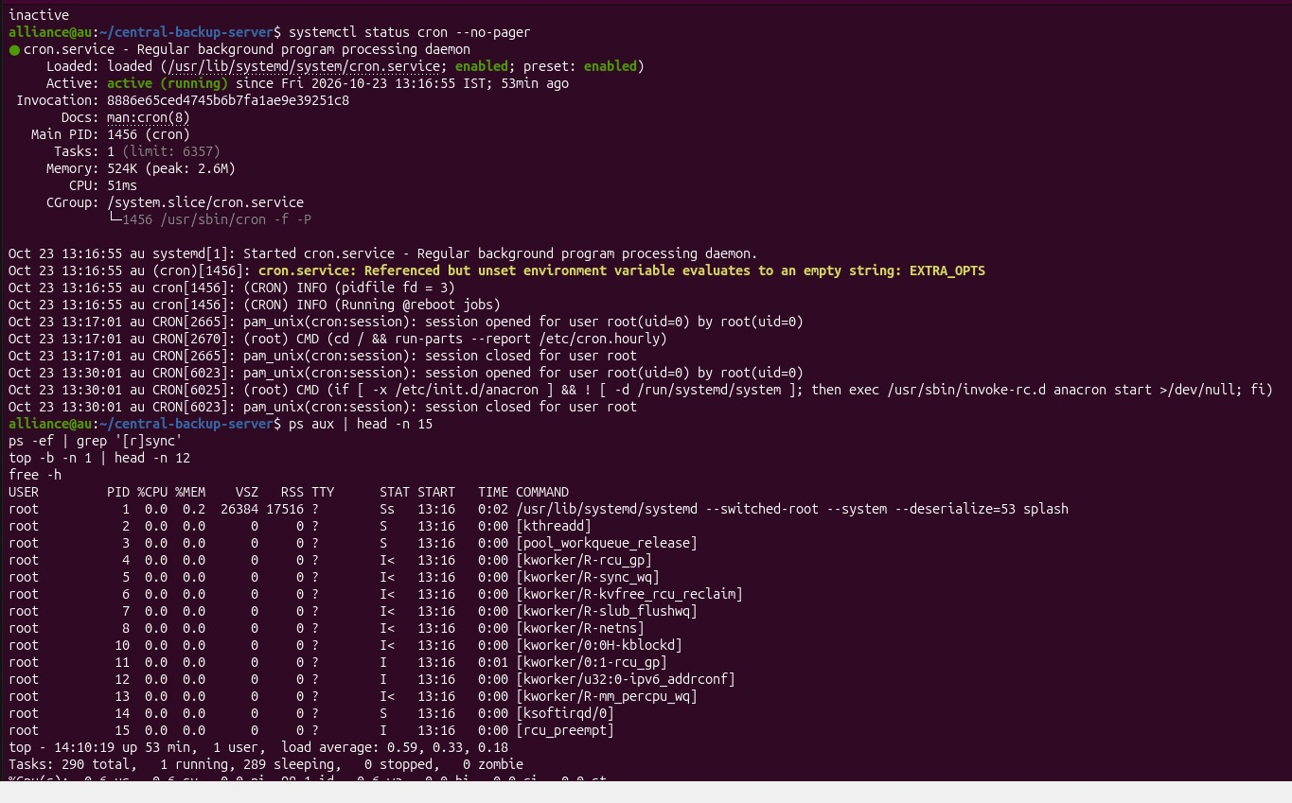
Figure 3.15(b): Actual capture from the project VM – cron service status and process listing

3.5.5 Process Termination
The kill command stops a process by its process ID (PID). If a backup hangs, the PID of the rsync process is checked carefully and the process is terminated gracefully. The script then removes the incomplete snapshot.
sleep 300 &
ps -ef | grep [s]leep
kill <PID>

3.5.6 Service Management
The cron and ssh services are managed with systemctl. They can be started, stopped, restarted, enabled at boot, and checked for status.
systemctl status cron --no-pager
sudo systemctl restart ssh
systemctl is-enabled cron ssh
crontab -l

3.6 Storage and File System Configuration
Storage is the most important part of a backup server. Backups are stored on a dedicated disk, separate from the operating system disk, so that a failure of the system disk does not destroy the backups. LVM is used so that the backup volume can be extended later without reinstalling or moving data.

3.6.1 Disk and Partition Configuration
A second virtual disk (/dev/sdb, 50 GB in the example) was added to the backup server. The lsblk and fdisk -l commands were used to identify the new disk before any change was made. The -e7 option of lsblk hides the snap loop devices.
lsblk -e7
sudo fdisk -l /dev/sdb

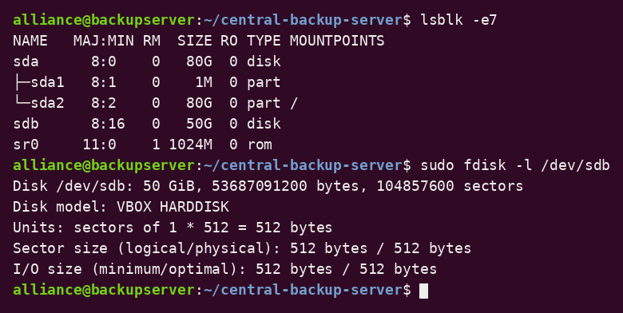
Figure 3.16: Disk identification (sample output)
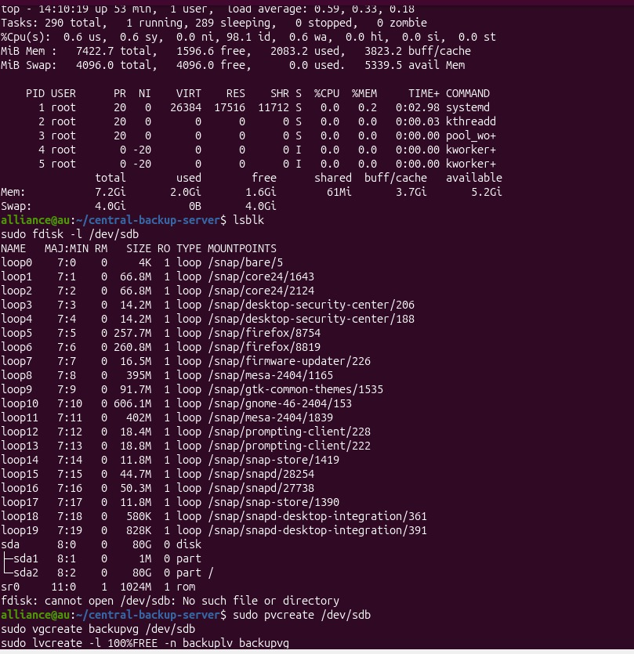
Figure 3.16(b): Actual capture from the project VM – top, lsblk and fdisk -l

3.6.2 File System Creation
The new disk was prepared with LVM, and an ext4 file system was created on the logical volume. The label BACKUPVOL identifies the volume.
sudo pvcreate /dev/sdb
sudo vgcreate backupvg /dev/sdb
sudo lvcreate -l 100%FREE -n backuplv backupvg
sudo mkfs.ext4 -L BACKUPVOL /dev/backupvg/backuplv

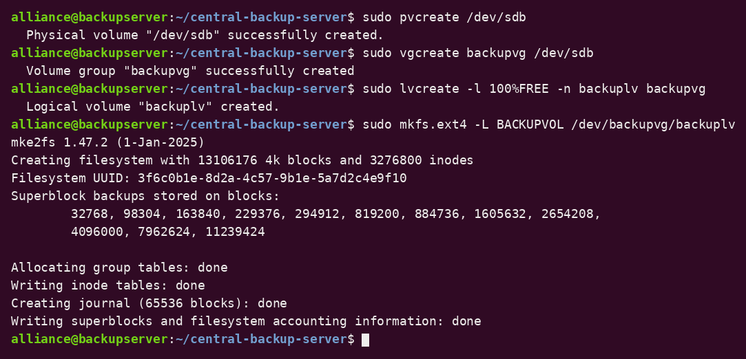
Figure 3.17: Logical volume and file system creation (sample output)

3.6.3 Mounting and Unmounting
The volume was mounted at /srv/backups. An entry using the file system UUID was added to /etc/fstab so that the volume mounts automatically at boot. The nofail option prevents a boot failure if the disk is missing. Mounting was verified with findmnt.
sudo mkdir -p /srv/backups
sudo mount /dev/backupvg/backuplv /srv/backups
sudo blkid /dev/backupvg/backuplv
# add to /etc/fstab (replace <UUID> with the value from blkid):
UUID=<UUID> /srv/backups ext4 defaults,nofail 0 2
sudo mount -a
findmnt /srv/backups

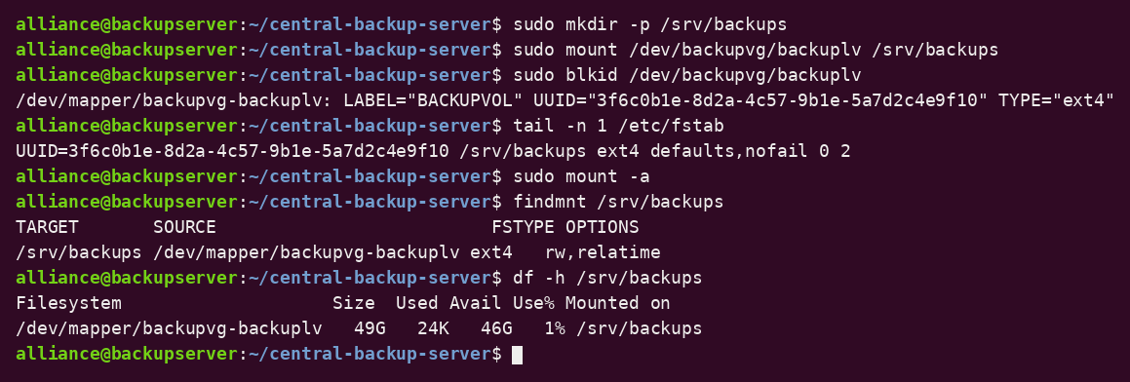
Figure 3.18: Mounted backup volume (sample output)
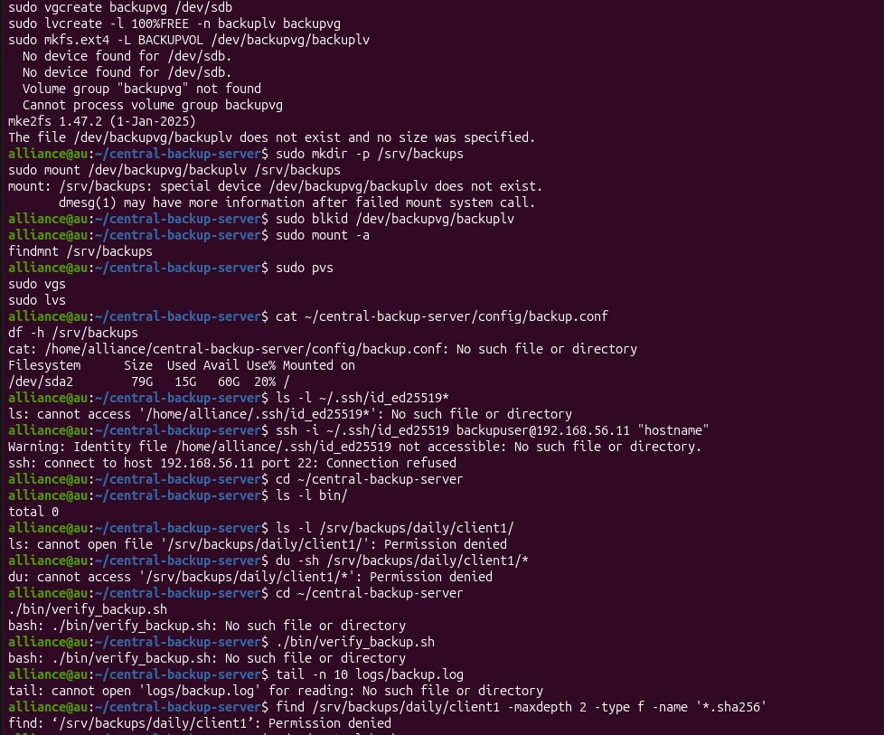
Figure 3.18(b): Actual capture from the project VM – LVM, mount, findmnt, pvs/vgs/lvs and SSH checks

3.6.4 Logical Volume Management (LVM)
LVM allows the backup volume to grow when more storage is needed. A new disk can be added to the volume group and the logical volume and file system extended while the server is running.
sudo pvs
sudo vgs
sudo lvs
# extending the volume later (example)
sudo pvcreate /dev/sdc
sudo vgextend backupvg /dev/sdc
sudo lvextend -r -l +100%FREE /dev/backupvg/backuplv

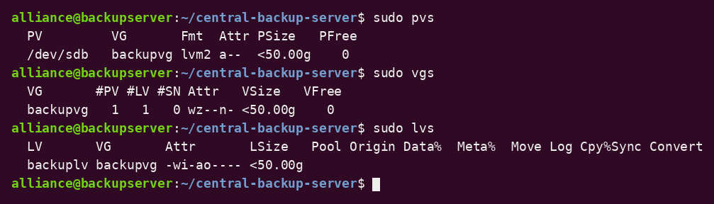
Figure 3.19: LVM status (sample output)

3.6.5 Storage Allocation
Storage allocation shows how the backup volume is divided between clients. The du command reports the space used by each client directory and snapshot. Because unchanged files are hard-linked, each new snapshot adds only the space for changed data.
du -sh /srv/backups/daily/*
du -h --max-depth=2 /srv/backups/daily/client1

3.6.6 Disk Usage Monitoring
Before each backup, backup_client.sh reads the usage of the backup volume with df. If usage reaches the warning threshold, a WARNING is logged; at the critical threshold the backup is aborted and a CRITICAL message is logged. The thresholds are defined in config/backup.conf:
- BACKUP_ROOT=/srv/backups
- DISK_WARNING=80
- DISK_CRITICAL=90
- DAILY_RETENTION_DAYS=7
- WEEKLY_RETENTION_DAYS=28
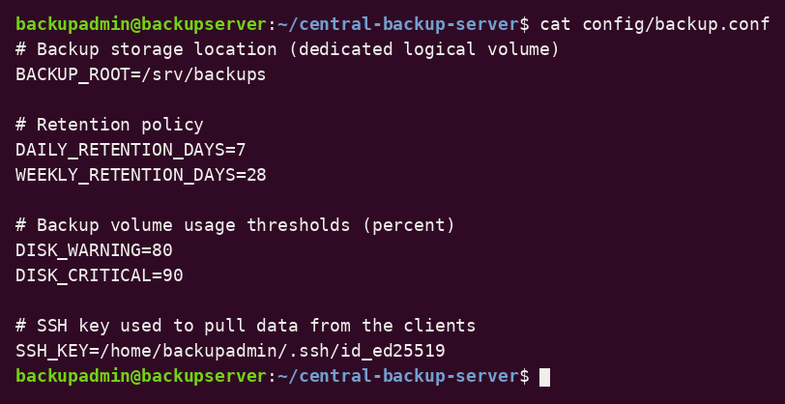
Figure 3.20: Backup configuration file (sample output)

3.6.7 Storage Architecture and Configuration Details
The storage architecture consists of the system disk (operating system, scripts, logs and reports) and a separate LVM-based backup volume. The backup volume contains daily snapshots, weekly archives, and checksum manifests. This separation protects the backups from system-disk failure and makes capacity planning simple.
Component | Details
Backup disk | /dev/sdb (separate virtual disk)
Volume group / logical volume | backupvg / backuplv
File system | ext4, label BACKUPVOL
Mount point | /srv/backups (UUID entry in /etc/fstab)
Owner / mode | backupadmin:backupgrp / 2770
Contents | daily/<client>/<snapshot>, weekly/*.tar.gz, *.sha256 manifests

3.7 Backup and Automation
Backup and automation are the core of this project. Backup protects data from loss, while automation makes the process regular and independent of the administrator.

3.7.1 Backup Strategy
The backup strategy combines incremental snapshots and weekly archives:
- Daily snapshots: every day rsync pulls each client’s data into a new timestamped directory. Unchanged files are hard-linked to the previous snapshot, so each snapshot appears as a full backup but uses little extra space.
- Weekly archives: every Sunday the newest snapshot is compressed into a tar.gz archive, which can be copied to external media.
- Integrity verification: a SHA-256 manifest is recorded for each snapshot and checked later to detect corruption.
- Retention: daily snapshots are kept for 7 days and weekly archives for 28 days; the newest snapshot is never removed.
- Pull model: the server connects to the clients, so clients cannot modify or delete backups.

3.7.2 Backup Location
Backups are stored on the dedicated volume mounted at /srv/backups. Daily snapshots are in /srv/backups/daily/<client>/<timestamp> and weekly archives in /srv/backups/weekly. The project scripts are in ~/central-backup-server/bin.

3.7.3 Backup Frequency
Task | Script | Schedule
Incremental backup of all clients | backup_client.sh | Daily at 02:00
Integrity verification | verify_backup.sh | Daily at 02:30
Retention cleanup | cleanup_old.sh | Daily at 03:00
Weekly compressed archive | weekly_archive.sh | Sunday at 04:00
Status report | backup_report.sh | Daily at 06:00

3.7.4 Shell Script Automation
Bash scripts automate every task. A shared file, common.sh, loads the configuration, defines the log file, and provides the log() and disk_usage_percent() functions. The complete scripts are given in Appendix C.
- backup_client.sh – checks backup volume usage, reads clients.list, and pulls an incremental snapshot from each client using rsync over SSH.
- verify_backup.sh – creates a SHA-256 manifest for the newest snapshot, or checks an existing manifest.
- cleanup_old.sh – removes snapshots and archives older than the retention period.
- weekly_archive.sh – creates a compressed archive of each client’s newest snapshot.
- restore.sh – restores a file or directory from any snapshot into a chosen target directory.
- backup_report.sh – generates the status report.

3.7.5 Cron Configuration
Cron runs the scripts at the scheduled times. The jobs were added with crontab -e as the backup administrator and verified with crontab -l.
0 2 * * * /home/backupadmin/central-backup-server/bin/backup_client.sh
30 2 * * * /home/backupadmin/central-backup-server/bin/verify_backup.sh
0 3 * * * /home/backupadmin/central-backup-server/bin/cleanup_old.sh
0 4 * * 0 /home/backupadmin/central-backup-server/bin/weekly_archive.sh
0 6 * * * /home/backupadmin/central-backup-server/bin/backup_report.sh

systemctl is-active cron
crontab -l
grep CRON /var/log/syslog | tail -n 10

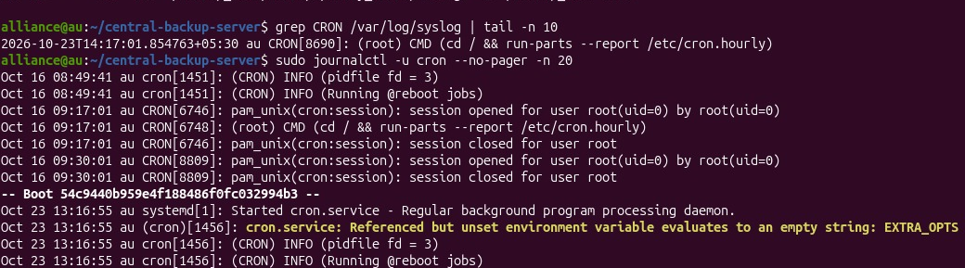
Figure 3.21: Cron service and scheduled job log
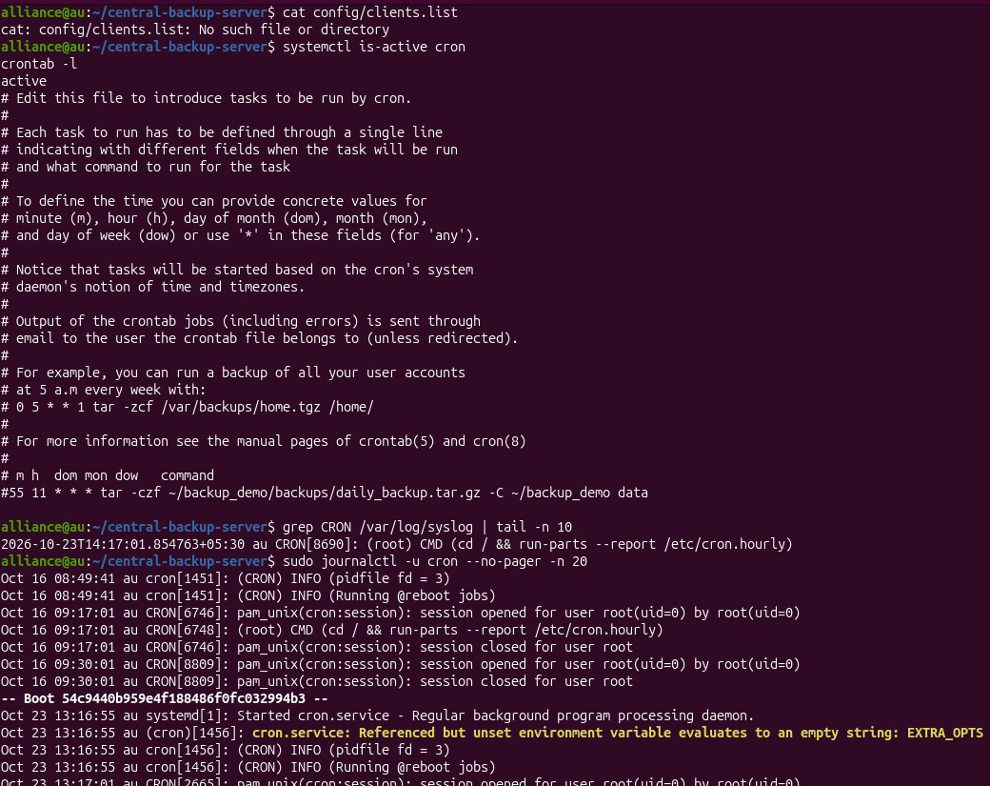
Figure 3.21(b): Actual capture from the project VM – crontab -l, syslog CRON entries and cron journal

3.7.6 Log Generation
Every action is recorded with a timestamp in logs/backup.log, for example START, SUCCESS, FAILED, MANIFEST, VERIFY OK, VERIFY FAILED, ARCHIVE, CLEANUP, and RESTORE. The status report is saved in reports/backup_report.txt.
- logs/backup.log – records all backup, verification, cleanup, archive, and restore events.
- /srv/backups/daily/<client>/<snapshot>.sha256 – checksum manifest of each verified snapshot.
- reports/backup_report.txt – generated backup status report.
cd ~/central-backup-server
tail -n 20 logs/backup.log
cat reports/backup_report.txt

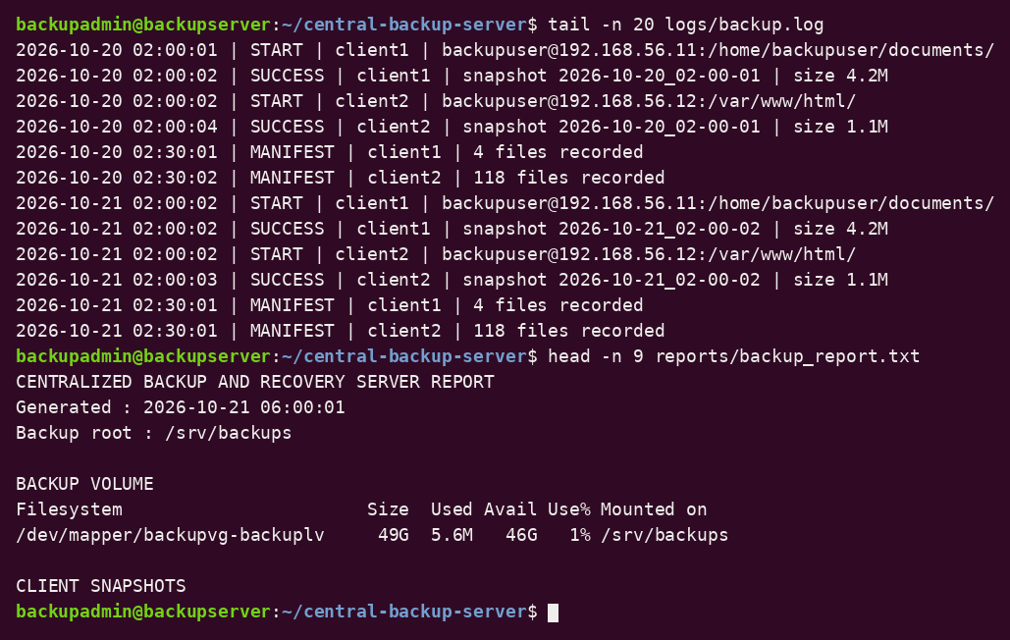
Figure 3.22: Backup log and report (excerpt) (sample output)
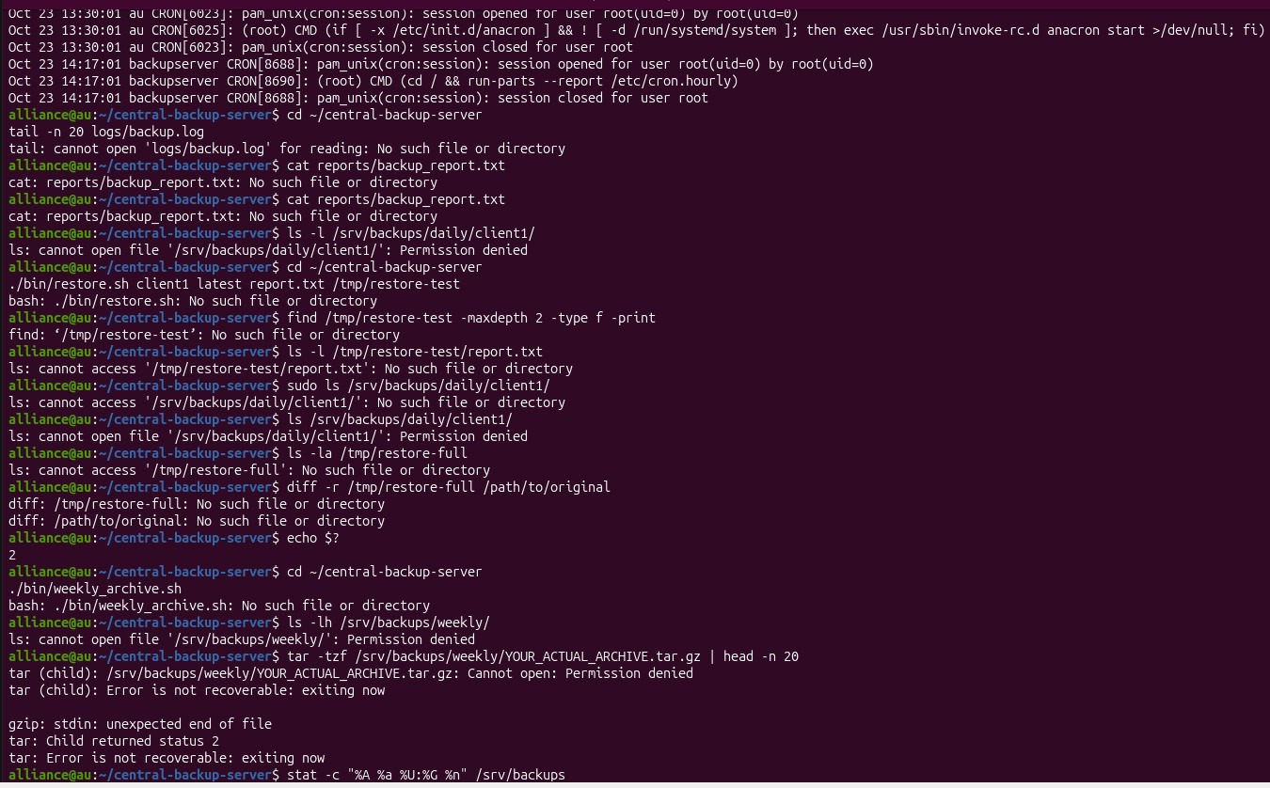
Figure 3.22(b): Actual capture from the project VM – project directory, log, report and script checks

3.7.7 Recovery Procedure
Recovery is performed with restore.sh. The administrator chooses a client, a snapshot (or latest), a path inside the snapshot, and a target directory. Restoring to a separate directory first prevents overwriting current files by mistake.
# list available snapshots of client1
ls /srv/backups/daily/client1/

# restore one file from the latest snapshot
./bin/restore.sh client1 latest report.txt /tmp/restore-test

# restore a complete snapshot to a separate directory
./bin/restore.sh client1 2026-10-20_02-00-01 . /tmp/restore-full

# compare recovered data with the source
diff -r /tmp/restore-full /path/to/original # empty output = identical

# restore from a weekly archive
mkdir -p /tmp/restore-archive
tar -xzf /srv/backups/weekly/client1_2026-W43.tar.gz -C /tmp/restore-archive

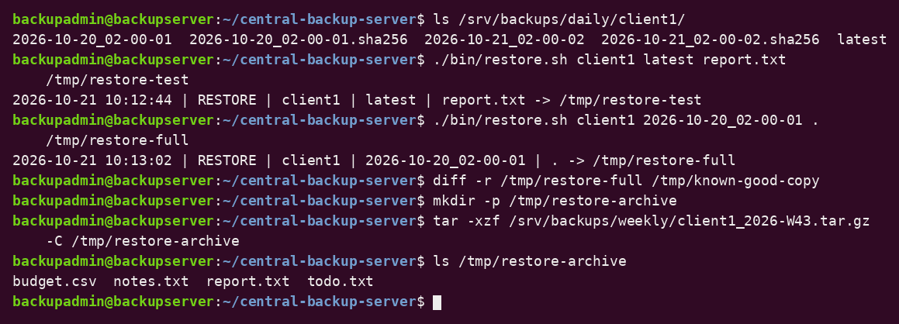
Figure 3.23: Recovery procedure (sample output)

3.7.8 Benefits of Automation
Automation removes manual effort and human error. Backups run at the same time every day, integrity is checked automatically, old data is removed without intervention, and the logs and reports show immediately whether any client failed. The hard-link snapshots allow many restore points without storing many full copies.

3.8 Security and Access Control
Backup data often contains sensitive information, so the server must be protected. Security is provided by separate accounts, restricted permissions, key-based SSH, and a firewall.

3.8.1 User Permissions
Only members of backupgrp can read the backup storage. Normal users have no access. The backup account on each client has read access only to the directories that are backed up.
id backupadmin
getent group backupgrp
ls -ld /srv/backups

3.8.2 File Permissions
The backup volume uses mode 2770, scripts and configuration use 750 and 640, and the private SSH key uses 600. A key with wider permissions is rejected by SSH.
stat -c "%A %a %U:%G %n" /srv/backups ~/.ssh/id_ed25519 ~/central-backup-server/config/backup.conf

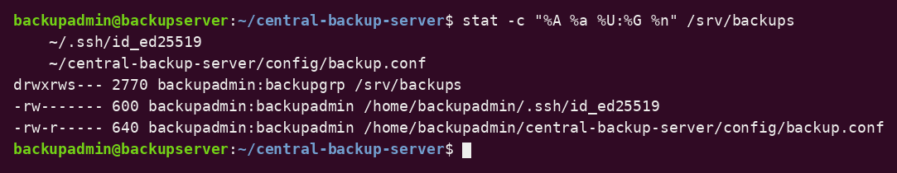
Figure 3.24: File permissions (sample output)

3.8.3 Firewall Configuration
UFW was used to allow only SSH from the private network and deny all other incoming connections. The rules were reviewed before enabling the firewall so that the administrator would not be locked out.
sudo ufw default deny incoming
sudo ufw default allow outgoing
sudo ufw allow from 192.168.56.0/24 to any port 22 proto tcp
sudo ufw enable
sudo ufw status verbose

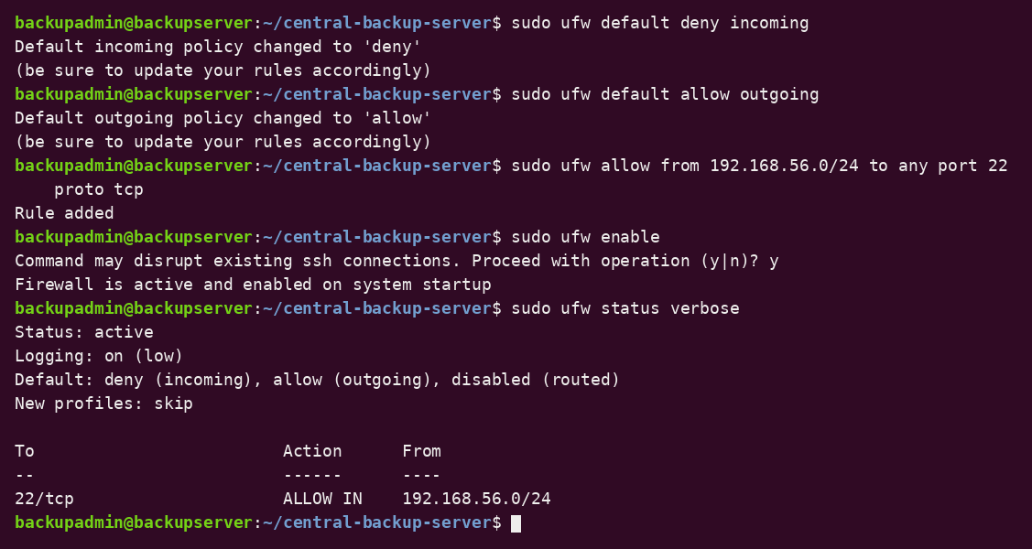
Figure 3.25: Firewall status (sample output)

3.8.4 SSH Configuration
A dedicated ed25519 key pair was generated for the backup administrator and the public key was installed on each client. Password logins for the backup user were disabled in the client’s SSH configuration, and the first connection was tested manually so that the host key was accepted.
ssh-keygen -t ed25519 -f ~/.ssh/id_ed25519 -C "backupserver"
ssh-copy-id -i ~/.ssh/id_ed25519.pub backupuser@192.168.56.11
ssh -i ~/.ssh/id_ed25519 backupuser@192.168.56.11 "hostname"

# on each client: /etc/ssh/sshd_config
PasswordAuthentication no
PermitRootLogin no

sudo systemctl restart ssh

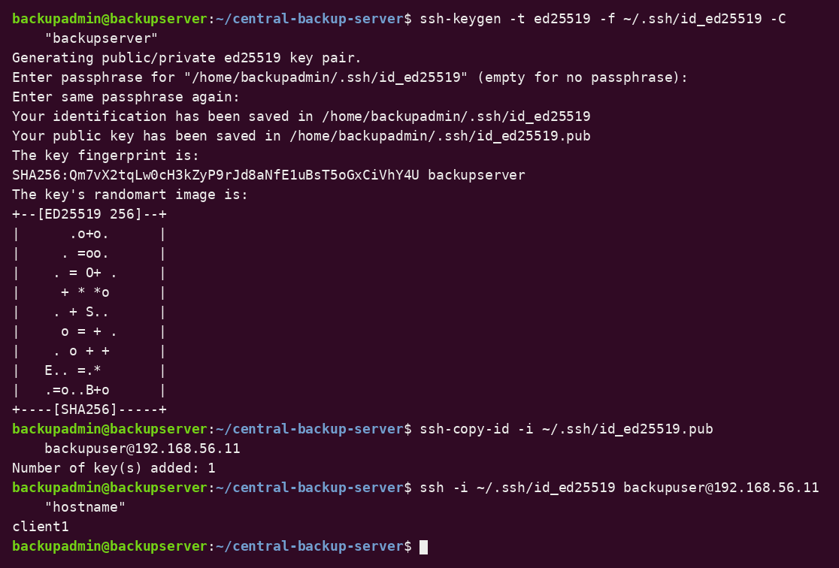
Figure 3.26: SSH key-based login (sample output)

3.8.5 Service Access Control
Only the services required by the project (ssh and cron) are active. Their status can be checked at any time, and unnecessary services should be disabled.
systemctl is-active ssh cron
sudo ss -tlnp

3.8.6 Password Policies
Passwords should be long, confidential, and changed periodically. Password aging information can be viewed and set with the chage command.
sudo passwd -S backupadmin
sudo chage -l backupadmin
sudo chage -M 90 backupadmin

3.8.7 Security Monitoring
Security checks include reviewing permissions, group membership, service status, SSH login attempts, and the backup log. Failed or unexpected logins appear in the authentication log.
sudo journalctl -u ssh --no-pager | tail -n 15
sudo grep "Failed password" /var/log/auth.log | tail -n 5
tail -n 20 ~/central-backup-server/logs/backup.log

3.8.8 Security Benefits
- Dedicated accounts and groups: limit who can access backup data.
- Permissions (2770/750/600): prevent unauthorized reading, writing, and execution.
- Pull model: a compromised client cannot delete or encrypt existing backups.
- Key-based SSH: removes password guessing and encrypts all transfers.
- Firewall: exposes only the SSH port to the private network.

4. Results and Testing

4.1 Implementation Results
The Centralized Backup & Recovery Server was implemented using Bash scripts, rsync over SSH, an LVM-based backup volume, cron scheduling, checksum verification, and a restore script. The implementation demonstrates Linux system administration concepts including user and group management, file permissions, package and process management, service management, storage configuration, security, and task automation.

4.1.1 Screenshots and Command Outputs
Screenshots of terminal outputs provide evidence of the implementation, including the project directory structure, mounted backup volume, backup and verification output, configuration, logs, reports, and restore tests. Captures taken directly on the project virtual machine are included in Appendix D.
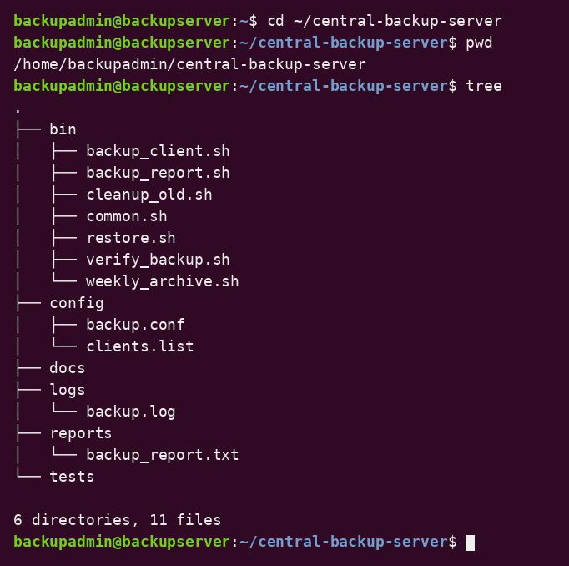
Figure 4.1: Project directory structure (sample output)

4.1.2 Backup Results
The first run of backup_client.sh creates a full snapshot of each client. Later runs create new snapshots in which unchanged files are hard-linked, so the additional space used is small. Each run records START and SUCCESS (or FAILED) entries in the log.
cd ~/central-backup-server
./bin/backup_client.sh
ls /srv/backups/daily/client1/
du -sh /srv/backups/daily/client1/*

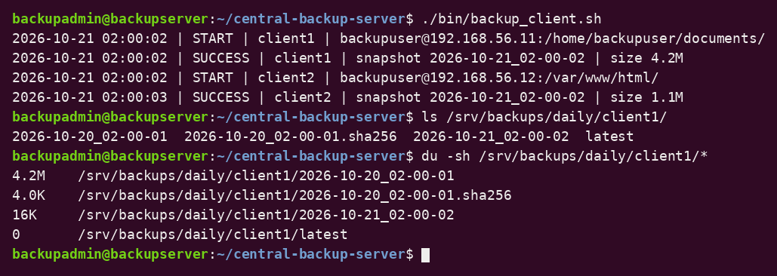
Figure 4.2: Backup run and snapshot listing (sample output)

4.1.3 Integrity Verification Results
verify_backup.sh records a SHA-256 manifest the first time it sees a snapshot and checks the files against that manifest on later runs. A modified or corrupted file is reported as VERIFY FAILED.
./bin/verify_backup.sh
./bin/verify_backup.sh
tail -n 5 logs/backup.log

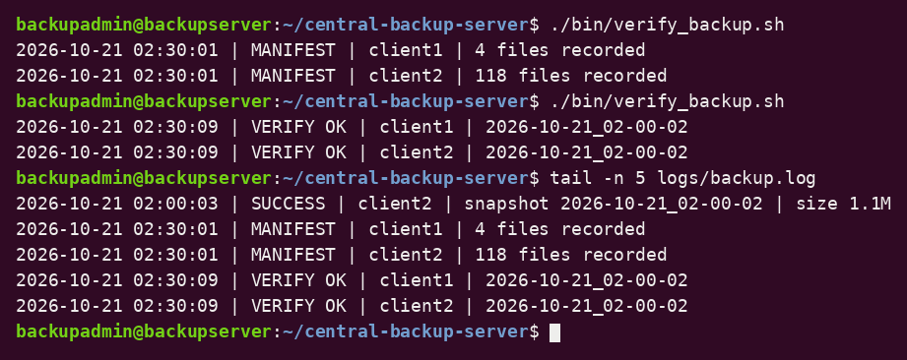
Figure 4.3: Integrity verification (sample output)

4.1.4 Configuration Results
The configuration defines the backup root, the retention periods (7 days for snapshots, 28 days for weekly archives), and the disk thresholds (80% warning, 90% critical).
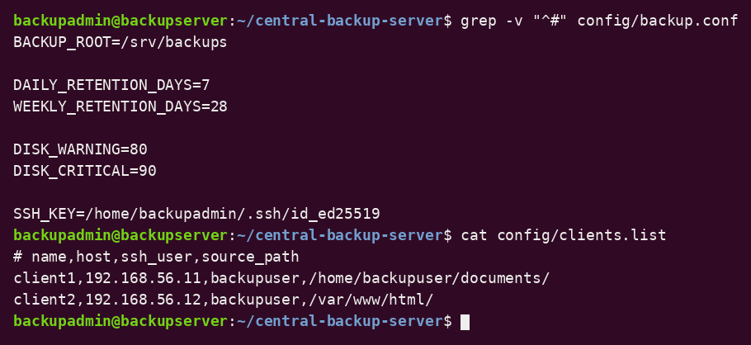
Figure 4.4: Configuration files (sample output)

4.1.5 System Status and Automation Results
Cron schedules the backup at 02:00, verification at 02:30, cleanup at 03:00, weekly archives on Sunday at 04:00, and the report at 06:00. The cron service status and job list confirm the schedule.
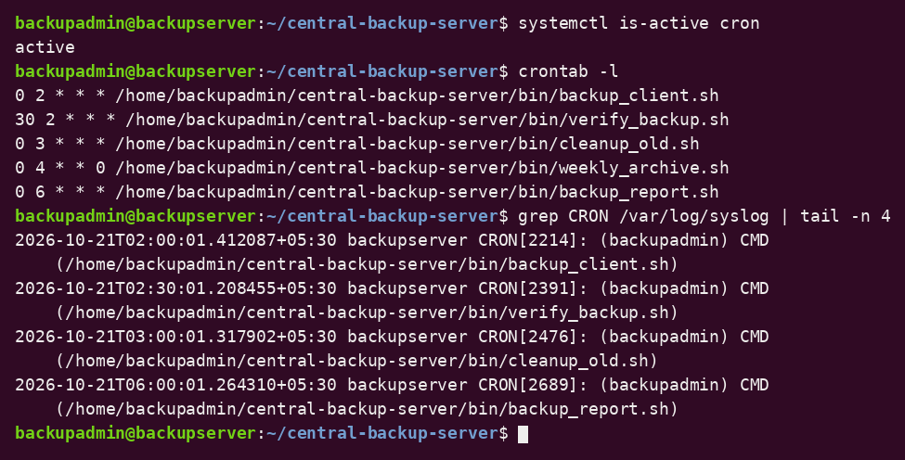
Figure 4.5: Cron service and job list (sample output)

4.1.6 Recovery Results
A file was deleted from a client and restored from the latest snapshot with restore.sh. A complete snapshot was also restored to a separate directory and compared with the source using diff. An empty diff output shows that the recovered data is identical.
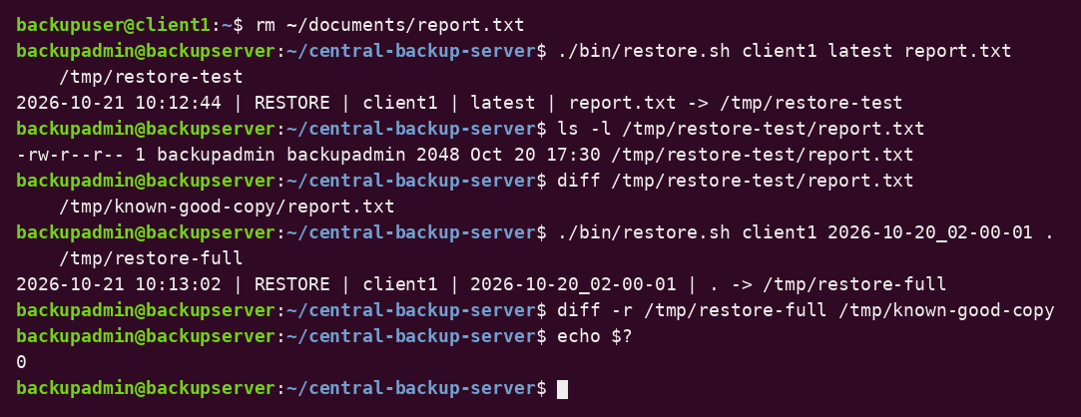
Figure 4.6: File and full recovery (sample output)

4.1.7 Log and Report Results
The log records every backup, verification, archive, cleanup, and restore event, and the report summarizes the volume usage, the snapshot count per client, the weekly archives, and recent failures.
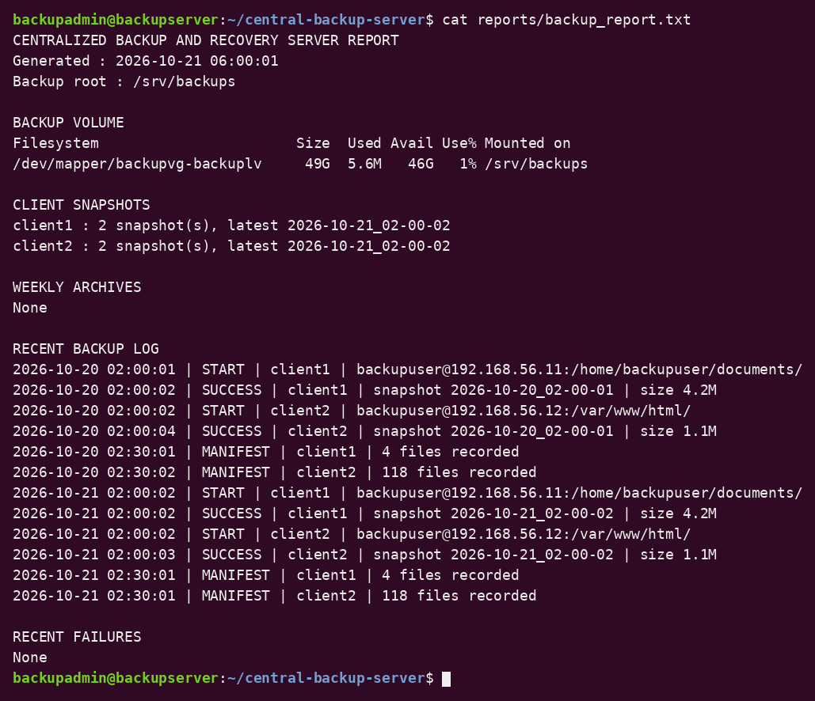
Figure 4.7: Backup report (sample output)

4.1.8 Security Configuration
The project uses dedicated users and groups, restricted permissions, key-based SSH, and UFW. Unauthorized users receive Permission denied when they try to read the backup volume.
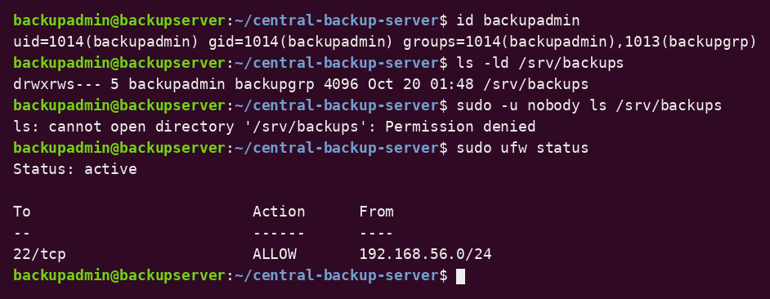
Figure 4.8: Security checks (sample output)
Overall, the implementation demonstrates a centralized Linux backup and recovery solution that combines secure transfer, incremental storage, verification, retention, scheduled execution, and tested recovery.

4.2 Testing and Validation
Testing was carried out to verify the main functions of the system. After running each test on your own setup, record the actual result and mark the status.
TABLE 1: TESTING AND VALIDATION

4.2.2 Recovery Testing
The recovery test deletes a known file from a client, restores it from the latest snapshot into a separate directory, and compares it with the original using diff. A complete snapshot is also extracted and compared. Recovery testing is always performed in a separate directory so that existing files are not overwritten.
rm ~/documents/report.txt # on client1
./bin/restore.sh client1 latest report.txt /tmp/restore-test
diff /tmp/restore-test/report.txt /path/to/known-good-copy # empty = identical

4.2.3 Integrity Test
To test corruption detection, one file inside the newest snapshot is modified deliberately and verify_backup.sh is run again. The script must log VERIFY FAILED and name the file. The snapshot is then deleted and a new backup is taken.
echo "corrupt" >> /srv/backups/daily/client1/latest/report.txt
./bin/verify_backup.sh # expected: report.txt: FAILED

4.2.4 Testing Summary
The tests cover the main features of the Centralized Backup & Recovery Server: user and group permissions, SSH access, package installation, storage configuration, incremental backup, integrity verification, retention, weekly archives, cron scheduling, recovery, and access control. They show how Linux administration tools and Bash scripts can provide reliable, automated backup and recovery with little manual work.

5. Conclusion and Future Scope

5.1 Conclusion
The Centralized Backup & Recovery Server provided practical experience in Linux system administration by implementing automated, pull-based backups of multiple clients. The project used Bash scripts, rsync, OpenSSH, LVM, cron, and standard Linux utilities to create incremental snapshots, weekly archives, integrity checks, retention management, logging, reporting, and recovery.
The project also demonstrated user and group management, file permissions and ownership, package and process management, storage configuration with LVM, firewall configuration, and key-based SSH access. The system was tested by running backups, verifying checksums, applying retention, restoring files and complete snapshots, and checking access control.
The project achieved its main objective of providing a secure, automated, and tested centralized backup and recovery solution, and it developed practical knowledge of Linux administration, storage management, automation, and security.

5.2 Future Scope
The project can be enhanced in the following ways:
- Off-site and cloud copies: copy weekly archives to cloud or remote storage to follow the 3-2-1 backup rule.
- Encryption: encrypt archives and the backup volume (LUKS) to protect data at rest.
- Email and chat alerts: send notifications when a backup or verification fails or when disk usage is high.
- Web dashboard: show client status, snapshot history, and storage usage in a browser.
- Database backups: add consistent dumps for MySQL/PostgreSQL before copying.
- Bare-metal recovery: add full system image backups for complete machine restoration.
- Automated restore tests: restore a random file every week and verify it automatically.
- Configuration management and containers: use tools such as Ansible or Docker to deploy the server and clients quickly.

References
- Ubuntu Documentation, Ubuntu Server Documentation. Available at: https://ubuntu.com/server/docs/.
- Rsync Project, rsync Documentation and Manual Page. Available at: https://rsync.samba.org/documentation.html.
- OpenBSD OpenSSH Project, OpenSSH Manual Pages. Available at: https://www.openssh.com/manual.html.
- GNU Project, GNU Bash Reference Manual. Available at: https://www.gnu.org/software/bash/manual/bash.html.
- GNU Project, GNU Tar Manual. Available at: https://www.gnu.org/software/tar/manual/tar.html.
- GNU Project, GNU Coreutils Manual. Available at: https://www.gnu.org/software/coreutils/manual/coreutils.html.
- Ubuntu Manpages, crontab – Maintains Crontab Files for Individual Users. Available at: https://manpages.ubuntu.com/.
- Linux Manual Pages Project, Linux Manual Pages (man pages), including lvm(8) and ufw(8). Available at: https://www.kernel.org/doc/man-pages/.

Appendices

Appendix A: System Architecture
Figure A1: System Architecture of Centralized Backup & Recovery Server

Appendix B: Linux Commands and Configuration
This appendix lists the important Linux commands used in the Centralized Backup & Recovery Server.

B.1 System Information Commands
whoami
hostname
hostnamectl
lsb_release -a

B.2 Project Directory Structure
cd ~/central-backup-server
pwd
tree
find . -maxdepth 2 -type f

B.3 Storage Commands
lsblk -e7
sudo pvs && sudo vgs && sudo lvs
df -h /srv/backups
findmnt /srv/backups
du -sh /srv/backups/daily/*

B.4 User, Group and Permission Commands
id backupadmin
getent group backupgrp
ls -ld /srv/backups
stat -c "%A %a %U:%G %n" /srv/backups

B.5 Backup and Recovery Commands
./bin/backup_client.sh
./bin/verify_backup.sh
./bin/cleanup_old.sh
./bin/weekly_archive.sh
./bin/backup_report.sh
./bin/restore.sh client1 latest . /tmp/restore-test

B.6 Cron, Service and Log Commands
systemctl is-active cron ssh
crontab -l
tail -n 20 logs/backup.log
cat reports/backup_report.txt

B.7 Security Commands
sudo ufw status verbose
ssh -i ~/.ssh/id_ed25519 backupuser@192.168.56.11 hostname
sudo journalctl -u ssh --no-pager | tail -n 15

B.8 Important Project Files
File or Directory | Purpose
bin/common.sh | Shared settings and helper functions
bin/backup_client.sh | Incremental backup of all clients
bin/verify_backup.sh | SHA-256 integrity verification
bin/cleanup_old.sh | Retention cleanup
bin/weekly_archive.sh | Weekly tar.gz archives
bin/restore.sh | Restore from snapshot
bin/backup_report.sh | Report generation
config/backup.conf | Backup path, retention and thresholds
config/clients.list | Clients to back up
logs/backup.log | Backup activity log
reports/backup_report.txt | Generated status report
/srv/backups/daily | Daily snapshots
/srv/backups/weekly | Weekly archives
TABLE 2: IMPORTANT PROJECT FILES

Appendix C: Shell Scripts
The following Bash scripts implement the main functions of the Centralized Backup & Recovery Server.

C.1 Shared Functions — bin/common.sh
#!/bin/bash
# Shared settings and helper functions used by all backup scripts.

BASE_DIR="$(cd "$(dirname "${BASH_SOURCE[0]}")/.." && pwd)"
CONFIG_FILE="$BASE_DIR/config/backup.conf"
CLIENT_FILE="$BASE_DIR/config/clients.list"
LOG_DIR="$BASE_DIR/logs"
LOG_FILE="$LOG_DIR/backup.log"

if [[ -f "$CONFIG_FILE" ]]; then
source "$CONFIG_FILE"
else
echo "Configuration file not found: $CONFIG_FILE" >&2
exit 1
fi

mkdir -p "$LOG_DIR"

log() {
echo "$(date '+%Y-%m-%d %H:%M:%S') | $1" | tee -a "$LOG_FILE"
}

disk_usage_percent() {
df -P "$BACKUP_ROOT" | awk 'NR==2 {gsub(/%/,"",$5); print $5}'
}

C.2 Backup Script — bin/backup_client.sh
#!/bin/bash
# Pull an incremental snapshot from every client listed in clients.list.
source "$(dirname "${BASH_SOURCE[0]}")/common.sh"

usage=$(disk_usage_percent)
if [[ -z "$usage" ]]; then
log "ERROR | Unable to read usage of $BACKUP_ROOT"
exit 1
elif (( usage >= DISK_CRITICAL )); then
log "CRITICAL | Backup volume is ${usage}% full - backup aborted"
exit 1
elif (( usage >= DISK_WARNING )); then
log "WARNING | Backup volume is ${usage}% full"
fi

timestamp=$(date '+%Y-%m-%d_%H-%M-%S')
failed=0

while IFS=',' read -r name host user path; do
[[ -z "$name" || "$name" == \#* ]] && continue
dest="$BACKUP_ROOT/daily/$name"
snapshot="$dest/$timestamp"
mkdir -p "$dest"

# Unchanged files are hard-linked to the previous snapshot (saves space)
link_opt=()
[[ -d "$dest/latest" ]] && link_opt=(--link-dest="$(readlink -f "$dest/latest")")

log "START | $name | $user@$host:$path"
if rsync -a --delete "${link_opt[@]}" \
-e "ssh -i $SSH_KEY -o BatchMode=yes -o ConnectTimeout=10" \
"$user@$host:$path" "$snapshot/"; then
ln -sfn "$snapshot" "$dest/latest"
size=$(du -sh "$snapshot" | cut -f1)
log "SUCCESS | $name | snapshot $timestamp | size $size"
else
rm -rf "$snapshot"
log "FAILED | $name | rsync returned an error"
failed=1
fi
done < "$CLIENT_FILE"

exit $failed

C.3 Integrity Verification — bin/verify_backup.sh
#!/bin/bash
# Create or check SHA-256 manifests for the newest snapshot of each client.
source "$(dirname "${BASH_SOURCE[0]}")/common.sh"

status=0
for dest in "$BACKUP_ROOT"/daily/*/; do
[[ -L "${dest}latest" ]] || continue
name=$(basename "$dest")
snapshot=$(readlink -f "${dest}latest")
manifest="$snapshot.sha256"

if [[ ! -f "$manifest" ]]; then
(cd "$snapshot" && find . -type f -print0 | xargs -0 -r sha256sum) > "$manifest"
log "MANIFEST | $name | $(wc -l < "$manifest") files recorded"
elif (cd "$snapshot" && sha256sum --check --quiet "$manifest"); then
log "VERIFY OK | $name | $(basename "$snapshot")"
else
log "VERIFY FAILED | $name | $(basename "$snapshot")"
status=1
fi
done
exit $status

C.4 Retention Cleanup — bin/cleanup_old.sh
#!/bin/bash
# Apply the retention policy to daily snapshots and weekly archives.
source "$(dirname "${BASH_SOURCE[0]}")/common.sh"

for dest in "$BACKUP_ROOT"/daily/*/; do
[[ -d "$dest" ]] || continue
name=$(basename "$dest")
keep=$(readlink -f "${dest}latest" 2>/dev/null)
while IFS= read -r -d '' old; do
[[ "$old" == "$keep" ]] && continue # never remove the newest snapshot
rm -rf "$old" "$old.sha256"
log "CLEANUP | $name | removed $(basename "$old")"
done < <(find "$dest" -mindepth 1 -maxdepth 1 -type d -name '20*' \
-mtime +"$DAILY_RETENTION_DAYS" -print0)
done

find "$BACKUP_ROOT/weekly" -type f -name '*.tar.gz' \
-mtime +"$WEEKLY_RETENTION_DAYS" -print -delete 2>/dev/null |
while read -r file; do
log "CLEANUP | weekly | removed $(basename "$file")"
done

C.5 Weekly Archive — bin/weekly_archive.sh
#!/bin/bash
# Create a compressed weekly archive of the newest snapshot of each client.
source "$(dirname "${BASH_SOURCE[0]}")/common.sh"

week=$(date '+%G-W%V')
mkdir -p "$BACKUP_ROOT/weekly"

for dest in "$BACKUP_ROOT"/daily/*/; do
[[ -L "${dest}latest" ]] || continue
name=$(basename "$dest")
archive="$BACKUP_ROOT/weekly/${name}_${week}.tar.gz"
if tar -czf "$archive" -C "$(readlink -f "${dest}latest")" .; then
log "ARCHIVE | $name | $(basename "$archive") | $(du -h "$archive" | cut -f1)"
else
rm -f "$archive"
log "ARCHIVE FAILED | $name"
fi
done

C.6 Restore Script — bin/restore.sh
#!/bin/bash
# Restore files from a snapshot into a separate target directory.
# Usage: restore.sh <client> <snapshot|latest> <relative-path|.> <target-dir>
source "$(dirname "${BASH_SOURCE[0]}")/common.sh"

if [[ $# -ne 4 ]]; then
echo "Usage: $0 <client> <snapshot|latest> <relative-path|.> <target-dir>" >&2
exit 2
fi

client="$1"; snap="$2"; rel="$3"; target="$4"

if [[ "$rel" == *..* ]]; then
echo "Path must stay inside the snapshot." >&2
exit 2
fi

source_dir="$BACKUP_ROOT/daily/$client/$snap"
if [[ ! -d "$source_dir" ]]; then
echo "Snapshot not found: $source_dir" >&2
exit 1
fi

mkdir -p "$target"
if rsync -a "$source_dir/$rel" "$target/"; then
log "RESTORE | $client | $snap | $rel -> $target"
else
log "RESTORE FAILED | $client | $snap | $rel"
exit 1
fi

C.7 Report Generation — bin/backup_report.sh
#!/bin/bash
# Generate a plain-text backup status report.
source "$(dirname "${BASH_SOURCE[0]}")/common.sh"

REPORT_DIR="$BASE_DIR/reports"
REPORT_FILE="$REPORT_DIR/backup_report.txt"
mkdir -p "$REPORT_DIR"

{
echo "CENTRALIZED BACKUP AND RECOVERY SERVER REPORT"
echo "Generated : $(date '+%Y-%m-%d %H:%M:%S')"
echo "Backup root : $BACKUP_ROOT"
echo
echo "BACKUP VOLUME"
df -h "$BACKUP_ROOT"
echo
echo "CLIENT SNAPSHOTS"
for dest in "$BACKUP_ROOT"/daily/*/; do
[[ -d "$dest" ]] || continue
count=$(find "$dest" -mindepth 1 -maxdepth 1 -type d -name '20*' | wc -l)
latest=$(basename "$(readlink -f "${dest}latest")")
echo "$(basename "$dest") : $count snapshot(s), latest $latest"
done
echo
echo "WEEKLY ARCHIVES"
ls -lh "$BACKUP_ROOT/weekly" 2>/dev/null || echo "None"
echo
echo "RECENT BACKUP LOG"
tail -n 15 "$LOG_FILE"
echo
echo "RECENT FAILURES"
failures=$(grep -E 'FAILED|CRITICAL' "$LOG_FILE" | tail -n 5)
echo "${failures:-None}"
} > "$REPORT_FILE"

echo "Report generated: $REPORT_FILE"

C.8 Configuration — config/backup.conf
# Backup storage location (dedicated logical volume)
BACKUP_ROOT=/srv/backups

# Retention policy
DAILY_RETENTION_DAYS=7
WEEKLY_RETENTION_DAYS=28

# Backup volume usage thresholds (percent)
DISK_WARNING=80
DISK_CRITICAL=90

# SSH key used to pull data from the clients
SSH_KEY=/home/backupadmin/.ssh/id_ed25519

C.9 Client List — config/clients.list
# name,host,ssh_user,source_path
client1,192.168.56.11,backupuser,/home/backupuser/documents/
client2,192.168.56.12,backupuser,/var/www/html/

Appendix D: Terminal Screenshots from the Project Environment
The screenshots below were captured directly in the terminal of the project virtual machine (user alliance, hostname au) on 23 October 2026. They appear in the report body next to the section they support, as the (b) figures listed here.
Figure | Section | Content of capture
Figure 3.12(b) | 3.3.7 Access Control | Permissions on /srv/backups, sudo -u nobody test, apt update, tool versions
Figure 3.15(b) | 3.5.4 Process Monitoring | Cron service status, ps aux, top, free
Figure 3.16(b) | 3.6.1 Disk and Partition Configuration | top, lsblk, fdisk -l
Figure 3.18(b) | 3.6.3 Mounting and Unmounting | LVM commands, mount, findmnt, pvs/vgs/lvs, SSH checks
Figure 3.21(b) | 3.7.5 Cron Configuration | crontab -l, syslog CRON entries, cron journal
Figure 3.22(b) | 3.7.6 Log Generation | Project directory, log, report and script checks

